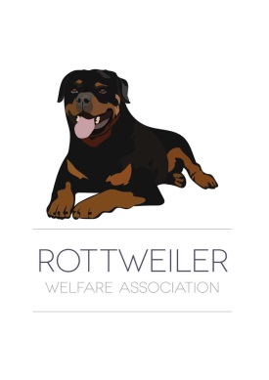
ROTTWEILER WELFARE ASSOCIATION
Registered Charity No 279 478-R
www.rottweilerwelfare.co.uk
Email:enquiries@rottweilerwelfare.co.uk Tel 07946 083070

RELINQUISHMENT OF OWNERSHIP/TAKEN INTO CARE QUESTIONNAIRE

To provide the best care for your dog, it is necessary to have your dog’s behavioral and medical histories available for review. Please complete the following information so we may get to know your dog better and obtain their medical records from your veterinarian.

Dogs Name: ____________________ Age now: _________How old was the dog when you had it:____
Gender M or F _________
Microchip Number ______________________
Reason for Relinquishing Dog: _______________________________________________________________________________
________________________________________________________________________________
________________________________________________________________________________

Is your dog speyed/neutered Y/N If Yes when_________________________
Do you have other pets? Y or N If yes indicate ______________________
How does your dogs behave around family? Indicate ages of adults/children in household.
_____________________________________________________________________________________
- Around strangers? ______________________________________________
- Around children? ________________________________________________
- Around other animals ____________________________________________

What are some of your dogs favourite games, toys or activties?___________________________________

Is the dog house trained? Y or N
Does the dog bark excessively? Y or N. If yes, please explain __________________________________
Has the dog ever bitten anyone: Y or N if yes, please explain circumstances: _______________________

Is the dog trained to walk on a lead? Y or N

Up to date picture of the dog:

All medical issues must be declared __________________________________________
_______________________________________________________________________

Please provide vets details _________________________________________________

I give permission for Rottweiler Welfare to contact my vets and obtain all medical history

Signature ___________________ Print Name _______________ Date ________

I/We the undersigned hereby relinquishment all claims on the above mentioned Rottweiler Dog/Bitch which is my/our sole property. I/We understand that my dog is now the property of Rottweiler Welfare Association and as such I have no further claim.
(To be signed by all owners, if a stray to be signed by the finder/keeper)
Name and address of owner/s________________________________________________
________________________________________________________________________
_________________________________________________Postcode________________
Tel__________________Mobile_________________Email_________________________
Signed by owner/s_________________________________________________________
I have given a donation of £______ to contribute towards the care of my Rottweiler.
Received by______________________________Rep for________________Area
One copy to be sent to Rehoming co-ordinator within 48 hours One copy to be given to owner.

To be filled in only when transfer is complete
Kennels__________________________________________________
Nervous Y/N Underfed Y/N Condition of coat? Good/Bad Condition of eyes? Good/Bad
Please return the completed form and any other papers to:
Mrs L Williams, R W A P.O Box 2424, Wrexham, LL11 0PR

